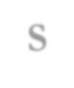
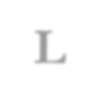
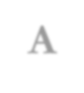
Southeastern Library Association
Ginny Frankenthaler Memorial Scholarship in Library Science
Complete and email to: mnero@southalabama.edu and include your last name in the subject line of the email.
APPLICATION FORM
Deadline: May 1, 2026 Please print.
Contact Information
Name: Date:
Mailing Address:
City: State: Zip:
Telephone: (home) (work) (cell)
Email Address:
Education: List all schools of higher education attended.
Institution with Address | Dates Attended | Major and Minor Fields of Study |  | Degrees and Dates
List any academic and/or professional honors you have received:
Employment History
Institution or Organization | Dates |  | Nature of Work
What library school do you plan to attend?
Will you be receiving other student aid, scholarship or assistance?  Yes  No
If yes, please specify including amount.
Month and year school term begins:
Month and year of expected completion of degree:
Do you plan to work in the Southeastern United States?  Yes  No
State your reasons for wanting to be a librarian and your ultimate professional goals. (Compose your response on a separate sheet and submit with the application.)
I certify that the information provided on this application is true and complete to the best of my knowledge.
_________________________________________________________ __________________________
Signature of Applicant Date

